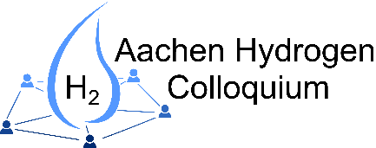
Call for Abstracts
Aachen Hydrogen Colloquium 2026

SupplHyInno Rhineland, the Hydrogen Clusters4Future initiative invites you to submit your abstract for a presentation at the Aachen Hydrogen Colloquium 2026.
The conference will focus on the following hydrogen related topics:
May 19 & 20, 2026 in Aachen
Deadline abstract submission:
January 31, 2026
Notification on acceptance:
March, 2025
Please send the abstract or address your questions to: colloquium@h2-cluster.de
- Generation via electrolysis and others
- Storage and transport
- Usage in the mobility sector
- Usage in industry
- Economy, LCA and social acceptance

Author(s)
First author
Institution
Address
E-Mail
Coauthor(s)
Institution(s)
Contact Speaker/Presenter
Contact person
E-Mail
Phone
Abstract
Type of submission | Please choose one option.
Topic | Please choose one option.
Keyword(s)
Title of abstract
Text abstract
(~ ½ page or
300 words)

