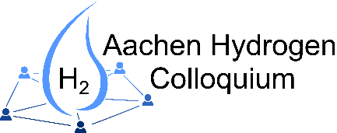
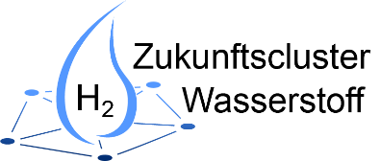
Call for Abstracts
Aachen Hydrogen Colloquium 2023

The „Zukunftscluster Wasserstoff“ invites you to submit your abstract for a presentation at the Aachen Hydrogen Colloquium 2023.
The conference will focus on the following hydrogen related topics:
April 18 & 19, 2023 in Aachen
Deadline abstract submission:
January 06, 2023
Notification on acceptance:
February, 2023
Please send the abstract or address your questions to: colloquium@h2-cluster.de
- Generation via electrolysis and others
- Storage and transport
- Usage in the mobility sector
- Usage in industry
- Economy, LCA and social acceptance

Author(s)
First author
Institution
Address
E-Mail
Coauthor(s)
Institution(s)
Contact
Contact person
E-Mail
Phone
Abstract
Topic
Keyword(s)
Title of abstract
Text abstract
(~ ½ page or
300 words)

